Haoyuan Qin (001048178)

**Program Structures & Algorithms**

**Fall 2021**

**Assignment No. 5**

* **Task (List down the tasks performed in the Assignment)**
* **Evidence to support the conclusion:**

**Output (Snapshot of Code output in the terminal)**

1. **Graphical Representation(Observations from experiments should be tabulated and analyzed by plotting graphs(usually in excel) to arrive on the ßrelationship conclusion)**

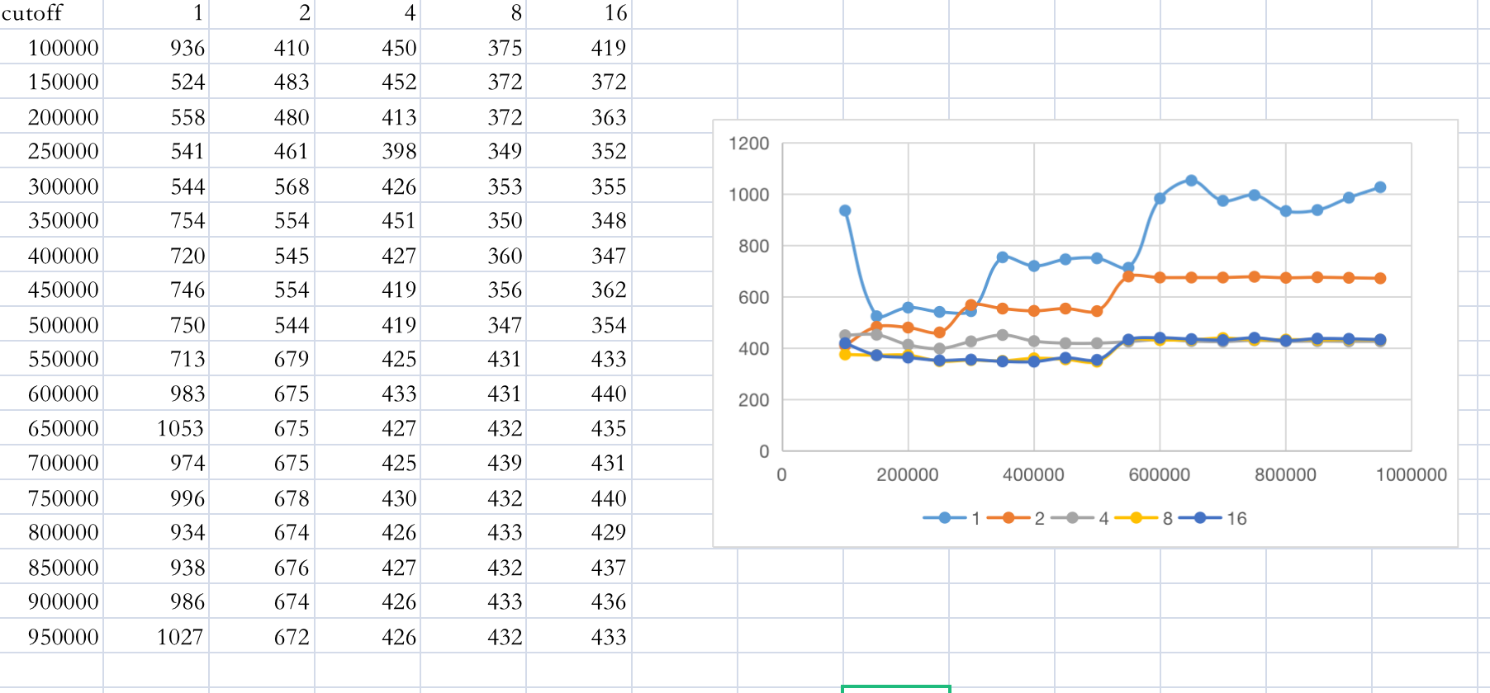

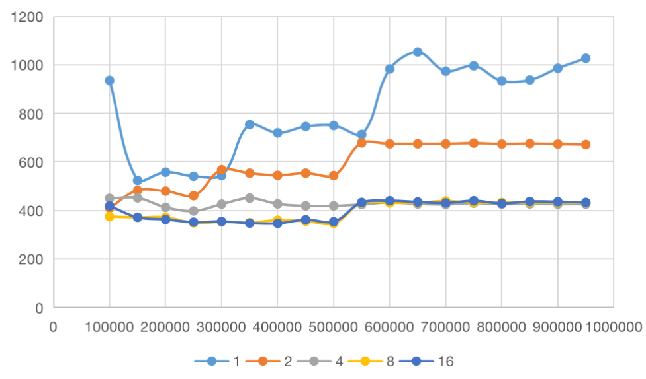X:cutoff Y: ms

We could find that there are only small differences between 4,8 and 16 threads. And the time will increase when the cutoff number is larger than 500,000 for 2,000,000 size of array. So then we do the experiment with 8 threads and cutoff number less than 500,000.

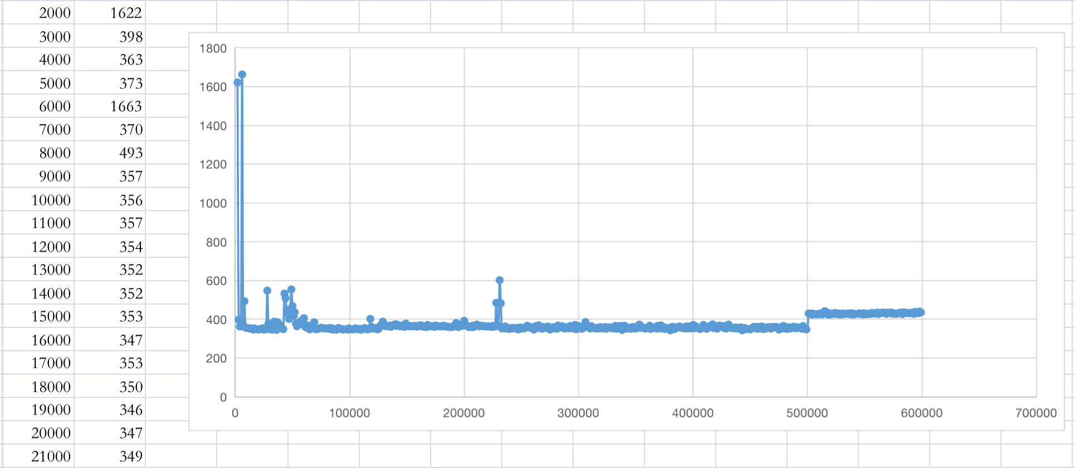

Here is the graph show the time spends on parsort when threads is 8. We can see there is not much different from about 50,000 to 500,000.

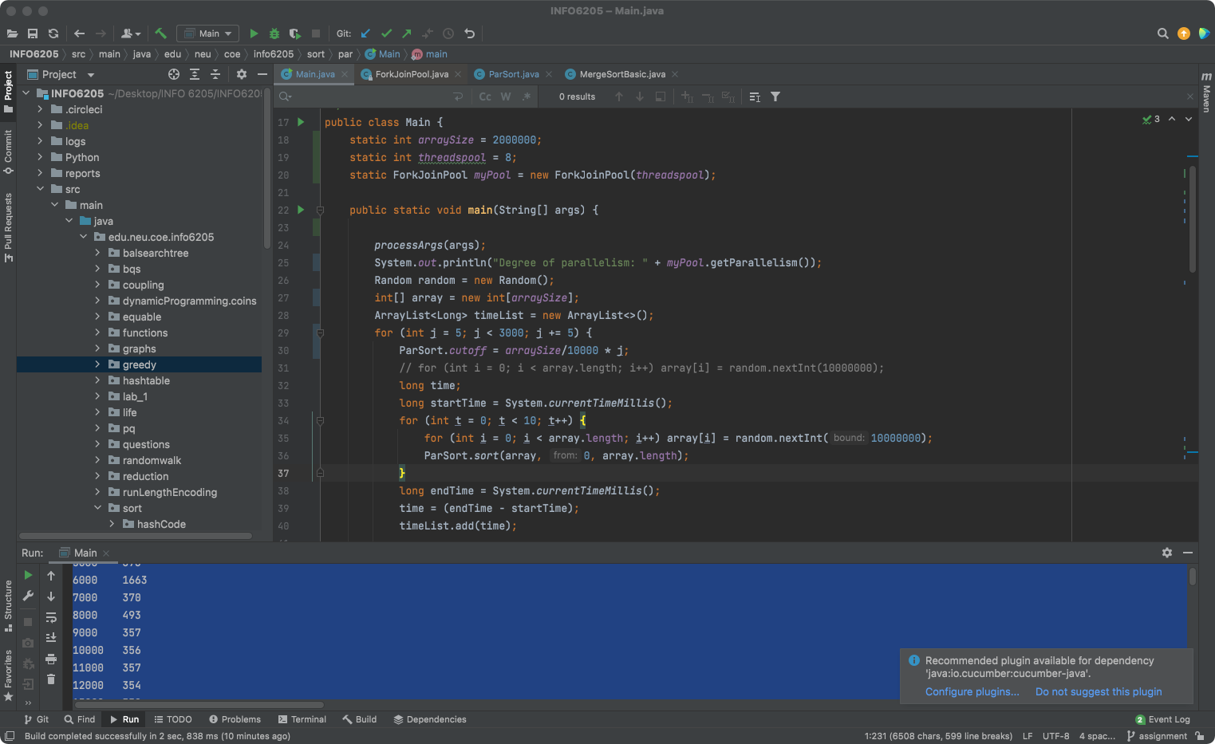

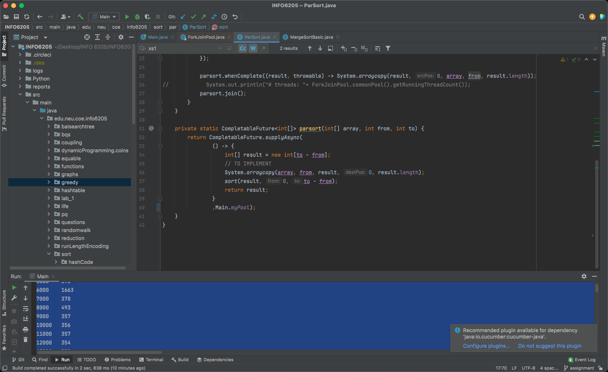

3.Your ****code**** ;

<https://github.com/Jim-Qin/INFO_6205_Assignments.git>